

South Lanarkshire
Community Planning Partnership

Working together to improve the quality of life for all in South Lanarkshire

Community Plan
for South Lanarkshire
2022-2032

Annual Outcome Improvement Report
2024-25

Contents

Chapter | Page Number
Introduction to Community Planning in South Lanarkshire  - Preface  - What are we?  - Who are we?  - What are we trying to do?  - How do I get involved? | 3
Our Ambitions  - Delivery of the Community Plan  - Collaboration for Health Equity in Scotland | 4-6
Community Plan  - Performance Highlights | 7
Community Plan  - Overall Performance at a glance | 8-9
Places for Wellbeing:  how we are making a difference  - Thriving Businesses and Fair Jobs  - Caring, connected communities  - People live the healthiest lives possible  - Putting learning at the centre  - Our children and young people thrive  - Good quality, sustainable housing for everyone | 10-19
Working with Communities:  how you can get involved  - Community Participation and Engagement  - Neighbourhood Planning  - Volunteering  - Community Asset Transfer  - Participation Requests | 20-28
Appendices  - Links to the National Performance Framework and UN Sustainable Development Goals  - Community Planning Partnership Structure | 29-30

Section 1 - Introduction to Community Planning in South Lanarkshire

What are we?
All our Community Planning Partners are working together to make South Lanarkshire a better place to live, learn, play, work and age. We work with each other and with communities to provide the best possible services that local people want and need. Further information can be found on the Community Planning Partnership website: www.southlanarkshirecommunityplanning.org.

Who are we?
Our partnership includes a wide range of national and local organisations. Some of these organisations you will know well. Our community partners lead on local planning and area-based Community Partnerships. A full list can be found on our website.

What are we trying to do?
Our aim is to work with communities to deliver better services targeted at reducing poverty and tackling inequalities and deprivation across South Lanarkshire. South Lanarkshire is also an Age Friendly Community, and the partnership works together with the Seniors Community to deliver on this. Further information can be found on the Community Planning Partnership website: www.southlanarkshirecommunityplanning.org.

How do I get involved?
There are many ways to get involved in your local community and influence the work of the partnership, for example, through volunteering, joining a local action group, helping to find out what matters in your area or getting involved in how decisions are made. More information can be found on the Community Planning website: www.southlanarkshirecommunityplanning.org/info/74/getting_involved.

Section 2 – Our Ambitions

Our Ambitions
Our Community Plan sets out how we will continue to support the people living in our communities to participate in Community Planning and puts the places where our communities live at the centre of change. We will continue to focus on improving how we work better together to deliver local needs and priorities.
This work will happen across three key ambitions: People; Progress; and Planet.
People – Together, we will take a people first approach to improving everyone’s wellbeing. People told us that empowerment comes from the community and it’s not something that is given to them. We understand that long-lasting change will only be achieved if we all work together, putting our communities at the heart of community planning. We will continue to have community conversations that matter. We will work with communities to ensure that their voices are heard and support them to act on the things that are important to them through a “Can Do” approach.
Progress – Together, we will build on what we have learned to improve how we do things and the wellbeing of everyone. Delivering the right things that matter to people, in the right place and at the right time. We have been inspired by the phenomenal community response to the global pandemic and have seen how our communities “Can Do” more with the right information and support from us. Our focus will be to continue to grow and develop the relationships and the excellent partnership working that has supported our communities to maintain and improve their wellbeing throughout the pandemic.
Planet - Together, we will act in ways that protect our natural world for a healthier future. We will work together to develop local solutions to protect nature and to take action on climate change and support our young people to lead the way.
The ambitions set out where we want to see change happening across the themes of Progress, People and Planet. From your feedback, we know that there are six other priorities that are important to you. We are working to improve services in these areas and have plans that show how this is being done. Our Places for Wellbeing model shows how the plan connects though place, ambitions and priorities.
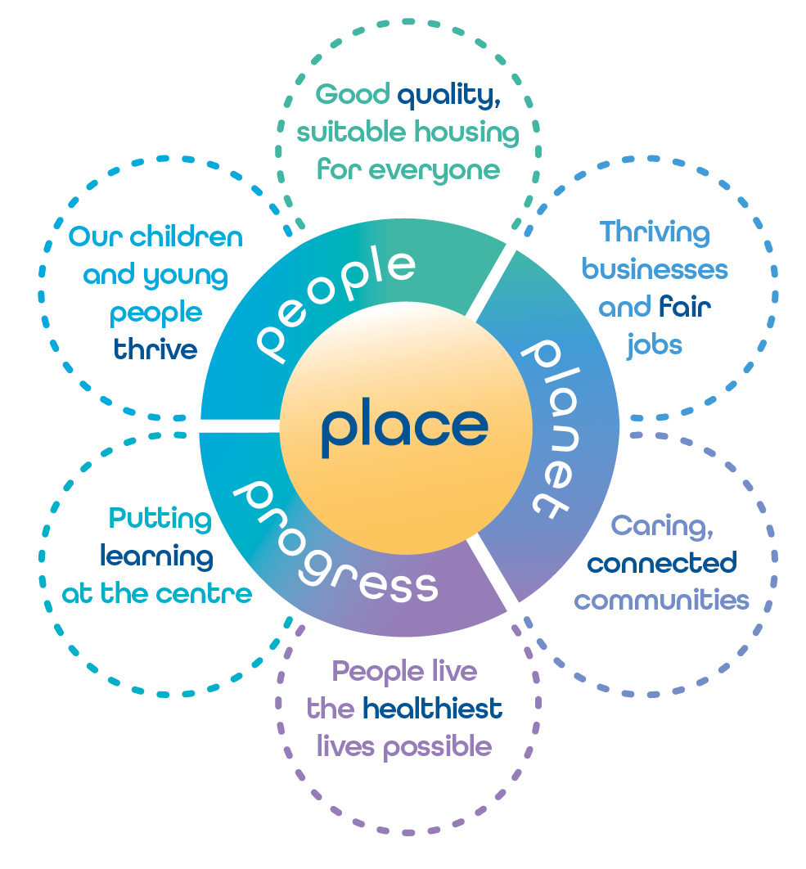

You can read the full Community Plan on the Community Planning website: www.southlanarkshirecommunityplanning.org/info/1/what_is_community_planning/135/our_priorities.

Collaboration for Health Equity in Scotland (CHES)
In winter 2024, the Community Planning Partnership were chosen as one of three places in Scotland to work with Public Health Scotland (PHS) and the University College London Institute of Health Equity (IHE), headed by Sir Michael Marmot, who have partnered to create the ‘Collaboration for Health Equity in Scotland’. This two-year collaboration between PHS and IHE aims to strengthen and accelerate the action underway to improve Scotland’s health, increase wellbeing and reduce health inequalities. Reducing health inequity requires action on eight key objectives. These are referred to as the Marmot 8 principles. They are to: -

- Tackle discrimination and racism, and their outcomes;
- Give every child the best start in life;
- Enable all children, young people and adults to maximise their capabilities and control their lives;
- Create fair employment and good work for all;
- Pursue environmental sustainability and health equity together;
- Ensure a healthy standard of living for all;
- Create and develop healthy and sustainable places and communities; and
- Strengthen the role and impact of ill health prevention.

Further information
Collaboration for Health Equity in Scotland - Public Health Scotland

Section 3 – Community Plan Performance Highlights

There is a significant amount of work being undertaken in our communities and by our partners across South Lanarkshire to make places fairer, better and greener. This report highlights some of the work that has been done.

The following are examples of key areas of work:

- Thriving Businesses and Fair Jobs: The number of employability participants progressing into employment has increased this year by 16.3%.
- Caring, connected communities: Focus groups were held with older people during October 2024 to consult on the World Health Organisation’s (WHO) Checklists for Age Friendly Cities.
- People live the healthiest lives possible: 3,756 co-produced Self-Directed Support Assessments were approved, exceeding the annual target of 3,000.
- Putting learning at the centre: 741 young people engaged in the Aspire Programme which included individualised one-to-one support; college-based leaver programmes and groupwork as they approached their school leaving date.
- Our children and young people thrive: 96% of parents who attended the ‘You and Your Child’ programme reported an improved understanding of their child’s developmental needs and how to meet these as parents.
- Good quality, sustainable housing for everyone: 95.6% of council stock met the Scottish Housing Quality Standard (SHQS) which is 24,789 properties.

Section 4 – Community Plan Overall Performance at a glance

The following provides a summary of our performance against our priority measures. These are:

- Putting learning at the centre
- Our children and young people thrive
- Thriving businesses and fair jobs
- Caring, connected communities
- People live the healthiest lives possible
- Good quality, sustainable housing for everyone

The full CPP performance report can be accessed using the following link: Https://bit.ly/CPP2425Q4ProgressReport

Status of priority measures
66
2
3
5
0
71 Improved or Maintained 5 Slippage or Deteriorated

Status | Definition
Blue | The action to achieve change has been completed
Green | On course to achieve the target or complete the action as planned/the timescale or target has been met as per expectations
Amber | There has been minor slippage against timescale or minor shortfall against target
Red | There has been major slippage against timescale or major shortfall against target
To be reported later | For some measures, the statistics are not yet available to allow us to say whether the target has been reached or not. These will be reported when available

Most improved measures | Least improved measures
Increase the percentage of employability participants progressing to positive destinations | Total number of businesses/social enterprises supported – Existing Organisations
By March 2025, 60% of children and young people accessing Pathfinders will report improvement across three outcome indicators | Number and value of grants
By March 2024, 100% of young people will have a Person-Centred Pathway Plan | Increase the percentage of Housing Option interventions where homelessness is prevented
Total number of jobs safeguarded | Reduce repeat instances of homelessness
Maintain the percentage of tenants in council new build properties who are satisfied with their home | Embed Home Assessment Team approach across localities to optimise independence of those discharged from hospital/prevention from hospital admission

Section 5 – Places for Wellbeing: How we are making a difference

Thriving Businesses and Fair Jobs – Living Wage

Why is this important?
The real Living Wage aims to reduce the impacts of poverty and inequality by helping employees whilst benefiting the employer and local economy. The real Living Wage is calculated on the UK cost of living, ensuring people are able to live with dignity and have a decent standard of living. In Scotland, this is currently £12.60 per hour. More recently, the Living Hours programme was launched, building upon the Living Wage accreditation in the campaign to end insecure work. Employers who join the scheme commit to:

- At least 4 weeks’ notice for every shift, with guaranteed payment if shifts are cancelled within this notice period;
- A guaranteed minimum of 16 working hours every week (unless the worker requests otherwise); and
- A contract that accurately reflects hours worked.

How are we doing?
In 2024-25, South Lanarkshire’s Living Wage Campaign Group met four times. In that period, they continued to support the Living Wage Accreditation Discount Scheme by providing grants to seven employers. The latest accreditation figures for South Lanarkshire are 186 employers which has made an impact on 2,500 employees. To promote and share awareness of the Living Wage with local employers, the group also hosted a breakfast event during Living Wage Week in November 2024, which resulted in a positive outcome, with an additional South Lanarkshire employer now accredited.

Throughout the year, group members focused on engagement with partners such as DWP, Skills Development Scotland and Routes to Work South Lanarkshire. This engagement, which is conducted on a daily basis, has the aim of ensuring that all relevant partners are aware of the benefits of the real Living Wage (benefits to employers, employees and the local economy). All partners are then able to promote the real Living Wage to businesses and employers.

Positive changes resulting from a review of the Living Wage Group, will continue into 2025-26. Moving forward, membership of the group will also include business representatives. This will ensure that the group has a clear focus for the year ahead and continues to create positive relationships and attract further interest from local employers and businesses.

Priority Next Steps
The Living Wage Group will continue to support the Living Wage Week and the Living Wage Accredited Discount Scheme. There will be an updated action plan which will align with the Glasgow City Region Living Wage Living Place Working Group. Membership of the group will be more business orientated to include the Chamber of Commerce, Business Gateway and local employers/businesses. The group will continue to raise awareness of the Living Wage Campaign including Living Hours and Living Pensions.

Further information
- For the real cost of living | Living Wage Foundation
- Support for Business - Social Enterprise Support
- Business Gateway
- The Poverty Alliance

Caring, connected communities – Planning: Local Development Plan 3

Why is this important?
South Lanarkshire Council’s Planning Service has started to prepare the new South Lanarkshire Local Development Plan (LDP3). Once adopted, LDP3 will set out the planning policies and proposals for the use and development of land throughout South Lanarkshire, over the next 10 years, to meet the needs of the area including where new homes, workplaces, healthcare, shops and community facilities could be built, and the areas that will be protected. It will focus on improving the quality of places and access to services to meet daily needs, addressing the challenges of climate change and protecting and enhancing biodiversity. LDP3 is currently in its first stage which involves the preparation of an Evidence Report which draws together data and statistics on different themes and feedback from engagement with communities.

People know their communities better than anyone, so to have a real understanding of community needs, the plan has to be co-designed in partnership with them and reflect what they say and what they want to see, where they live. Through listening to their lived experiences, we can identify what works well in their community and what needs protected, fixed, improved or provided. Data and statistics alone are of limited use, but when considered together with lived experiences, both are enriched, providing a stronger foundation from which to develop the proposed LDP3 to meet the needs of the area.

How are we doing?
The law requires that views are sought from residents, children and young people, disabled people, gypsies and travellers, community councils and key agencies. However, the Planning Service pledged to go even further and reached out directly to over 1,200 groups including those who don’t normally engage (seldom heard voices), older people, women/girls, men/boys, LGBTQ+, neurodiversity, vulnerable people (“protected characteristics” disabled, age, race, gender, sexual orientation), carers, tenants, developers/landowners and Third Sector Organisations.

Engagement communications sought to empower people to want to get involved by giving encouragement that their views were valuable and would help shape their places in the new plan. Participants chose the method of engagement that suited them best (survey/email/letter/telephone call/online or in-person meetings). They also controlled the extent of their contribution by only commenting on place themes of interest to them, and in meetings, they could feel comfortable even just to listen in. The Planning Service contacted all the groups mentioned above and most took up the offer to meet. By having cast the engagement net wider, the proposed LDP3 will be more robustly informed and inclusive, benefitting everyone and every place within South Lanarkshire.

What people have said about LDP3 Engagement Workshops:
“Thanks for enabling our children to share their views, they really enjoyed the session with you. Hopefully we will see you again.” Jackton Primary School.

“I've heard great feedback from having you on site. I'm delighted that the community have had a chance to get their voices heard.” The Beacons.

“I look forward to the next one and will encourage more people to attend.” East Kilbride/Strathaven Locality Event participant.

Priority Next Steps
Further engagement will take place to ask communities if they agree with what’s proposed for their community in the preparation of the proposed LDP3. The focus will be to build upon and nurture the network of collaborators, working relationships and trust that has been achieved so far. In doing so, the LDP3 once adopted, will reflect the collective diverse voices, each championing the uniqueness of South Lanarkshire’s communities of place and interest, but united by the common goal of making the best use of the land resource available to meet the needs of all communities.
Further information
- Local Development Plan 3 (LDP3) - South Lanarkshire Council

People live the healthiest lives possible – Keep Well

Why is this important?
Cardiovascular Disease (CVD) is a leading cause of mortality and morbidity in Scotland. Keep Well (KW), a small nurse led service, delivers a CVD prevention focused health check across Lanarkshire, to seven targeted populations and communities who may not readily access mainstream services. These groups include people affected by problematic substance use, people affected by homelessness, people attending Community Justice Services, members of the gypsy/traveller community, people who have an unpaid caring role, members of the Deaf community and people from ethnic minority backgrounds. There is strong evidence available to indicate that these communities and groups experience poorer health outcomes, not just related to CVD.

How are we doing?
The key to success and sustainability of KW, is collaboration with other services. KW have developed excellent partnerships with not only NHS Lanarkshire services, but with other Health and Social Care partners and Third Sector partners. Working with partner services, a traditional appointment-based approach is used, where partners can refer their patient/service user directly into the service. The team also use an opportunistic assertive outreach model, where the service is taken directly to the people the team wish to engage with. Here, people are seen outwith the traditional health care environment and clinics are delivered within a wide variety of settings, making them accessible to those who need them most in the community.

During 2024-25, KW engaged with 194 people from South Lanarkshire. It should be noted, however, that the total number is likely higher as some partner services provide a service across Lanarkshire, and residents from South Lanarkshire have attended clinics held in North Lanarkshire venues.

- 53% of people benefited from Case Management Support to link them into mainstream services to address their health and wellbeing needs;
- 42% required further management of abnormal clinical findings and were referred to their GP practice;
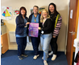
- 27% accepted referral to South Lanarkshire Leisure and Culture to improve their physical activity;
- 11% accepted testing for Blood Borne Virus detection;
- 3% were referred to Addiction Support Services; and
- 6% accepted referral to Homeless Cancer Screening and Sexual Health Nurse.

Priority Next Steps
- Continue to build on relationships with South Lanarkshire Council’s Restorative Justice and Women’s Hubs.
- Discuss the possibility of delivering the service to those attending Diversion from Prosecution Services along with the new Justice Group work programme.
- KW plan to shadow the Harm Reduction Team during their Outreach Service, and it is hoped that there will be further opportunities to work in partnership, delivering health checks to individuals using the Outreach Service.

“Great partnership working and we know the carers we support find the service so helpful to them” Partner Service staff member.

“Thank you so very much for helping me get the treatment I needed at my GP practice” Patient.

Further information: Keep Well | NHS Lanarkshire
Putting learning at the centre – Youth Forum on Climate Change and Sustainability

Why is this important?
Conference of Schools 3 Event
South Lanarkshire is committed to equipping young people with the tools and confidence to lead on issues that will shape their futures, none more pressing than climate change. Engaging students from P5–P7, the Conference of Schools (COS) 3 event planted early seeds of environmental responsibility, involving secondary pupils as mentors and role models. The event’s strong emphasis on sustainability aligns directly with South Lanarkshire’s Community Plan goals of climate resilience and youth empowerment.

How are we doing?
The third annual Youth Forum Conference brought together over 300 students and teachers from 100 primary schools, engaging them in hands-on learning activities designed and delivered by secondary students. Key workshops addressed renewable energy, sustainable fashion, biodiversity and waste reduction. Feedback from both staff and pupils highlighted the value and impact of the experience:
- “It was an extremely enjoyable day because we got to do fun activities but also learn all about looking after our environment.”
- “We want to have an event like this in school.”
- “I enjoyed getting to know about the problems of the Earth and how we can solve them.”
- “The connection between the pupils from secondary schools and primary schools was wonderful and to see them all working together on learning for sustainability.”
- “The most valuable aspect was seeing how engaged and passionate the children were about climate action.”

The collaborative format also strengthened bonds between primary and secondary learners, enhancing confidence, communication, and peer leadership. Teachers noted increased pupil enthusiasm for climate topics and a desire to carry this momentum into their classrooms.

Many attendees expressed a strong desire to replicate aspects of the event in their own school setting, particularly the practical, student-led workshop model. The wide variety of engaging activities, ranging from renewable energy experiments to creative upcycling tasks, proved effective in translating complex sustainability topics into accessible and memorable learning experiences. Importantly, the conference not only met its educational goals but also sparked meaningful dialogue about local action, fostering a culture where young people feel empowered to make a difference.

Priority Next Steps
- Enable schools to independently run mini versions of the conference by using the provided toolkit with the COS3 workshop presentations and activities.
- Offer tailored training for Youth Forum members to enhance their leadership, presentation and facilitation skills.

Further information
To find out more about the COS3 event please view the following link: COS3 Case Study

Our children and young people thrive – Children’s Rights in South Lanarkshire

Why is this important?
The United Nations Convention on the Rights of the Child (UNCRC) (Incorporation) (Scotland) Act 2024 provides a unique opportunity to work towards best practice in children’s rights in everything we do. Our approach is informed by the aspiration to help children access their rights more easily and the Children’s Services Partnership have been engaging with their wider workforce to help them understand children’s rights better, be more aware of the demands that incorporation will make on public services and to understand what best practice looks like.

The commitment to respect and promote the rights of all children and young people is central to the work we do, and this strong rights-based approach is making a significant difference to children and young people’s lives. We are listening to the voices of more children and young people than ever before, which in turn is informing our work and the work of the wider public sector. As a partnership, we aim to ensure that the voices and lived experiences of children, young people, parents and carers are embedded within all our planning processes, and we clearly understand the impact that they have on decisions we make. Our commitment to children’s rights and engagement participation is a strength and features in our Children’s Services Plan animation, designed and created by our children and young people: https://youtu.be/Sx_rrNiKOo8

How are we doing?
A selection of the many examples of children’s rights practice over the last year to support the implementation of the Act are shared below:
- A Child Friendly Complaints Model has been developed by South Lanarkshire Council’s Education Resources which looks at practice regarding complaints and supports children and young people to share their views when complaints about services that affect them are made. (Article 12 – the right to be heard).
- A UNCRC eLearning module has been created by our children and young people and has been made available across all public and third sector partners. This training puts children and young people at the heart of our rights-based practice and is a webinar that informs staff of the key messages in the UNCRC (Incorporation) (Scotland) Act 2024 (Article 42 - the right to know your rights).
- We continue to refresh our Getting It Right for Every Child (GIRFEC) website with the latest information and guidance on children’s rights, making sure staff are well informed about children’s rights and their role in supporting them. (Article 3 - the best interests of the child).
- Children and young people are more involved in the planning, delivery and participation in events:
- An event to celebrate Care Day in February 2025, was planned with and led by young people from our Champion’s Board. The young people hosted the event and challenged corporate parents to show how they were continuing to keep South Lanarkshire’s Promise. This event brought together over 180 care experienced children and young people and corporate parents to share experiences and identify what more we can do together. (Articles 9, 20 and 21 the right to be cared for).
- Our Wellbeing Warriors were at the heart of a conference in March 2025 helping to share good practice in schools across South Lanarkshire to support emotional wellbeing. The event also helped highlight other important supports that were available to support children and young people’s mental health and emotional wellbeing. (Article 24 – the right to health care).
- The care experienced Champions Board have been more visible to care experienced children and young people and to corporate parents. The Champions regularly host sessions with corporate parents to discuss all aspects of The Promise. This includes a regular visit from South Lanarkshire Council’s Chief Executive. (Article 12 - the right to be heard, Article 3 - the best interests of the child).
- We have introduced a ‘Mini Champs’ process and made sure that pupils in schools have the opportunity to be heard. (Article 12 - the right to be heard).
- Our Champions Board helped to make our Winter Wishes campaign a success and make sure that care experienced young people got extra help over the Winter period with cost of living challenges including access to food, winter clothing, help with paying bills and having their basic needs met, despite the challenges of the cost of living and price increases. (Article 27 - the right to food and clothing and a place to live).
- The Champions Board and young people from the Pathfinders project hosted a visit from Scottish Government Minister Natalie Don-Innes in July 2024 and helped launch a national consultation on ‘Moving on from Care’ from the Throughcare and Aftercare Hub. The young people were delighted to get the chance to meet, listen to and discuss issues and ideas with a member of the Scottish Government. (Article 4 - Governments have a responsibility to protect children’s rights);
- The national Promise Fund is helping support a reduction in the criminalisation of care-experienced young people who are over-represented in the justice system. Care and justice experienced young people are coming together through the ASK youth justice and rights approach to inform how best young people can be safeguarded in their communities. The work is being led by young leaders and peer researchers, supported by the council, COVEY and the University of the West of Scotland. (Article 19 - the right to be protected from harm, Article 40 - the right to help in the justice system).
- As part of a public consultation on council budgets, children and young people led 1,300 of their peers in a video led interactive process to make the views known throughout South Lanarkshire visible to decision makers. A report on their voice was published and made available to councillors as part of the engagement process. In a follow-up, elected members were asked what impact the views of children and young people had had on the process. Young people reported that they enjoyed the experience, and it was easy and fun to give their opinions on budget proposals and other issues affecting their lives. An annual ‘check in’ process will become a feature of community engagement. (Article 12 - the right to be heard).
- South Lanarkshire is one of three local authority areas to participate in the Marmot Place Programme, which offers a unique opportunity to improve our understanding of inequalities across South Lanarkshire. Young people spoke at the launch event in February 2025 for the programme and will be a visible and important part of this collaborative approach to address and reduce health inequality across our communities. (Article 24 - the right to the best possible health care and healthy environment).

Priority Next Steps
The work of our partnership is rooted in a rights respecting approach, supporting and informing our work and challenging staff to aspire to the best possible outcomes for all children and young people, particularly those who are most vulnerable. Over the next year and beyond, the following commitments will be a priority for our partnership:
- We will continue to promote rights-based practice, so all children’s voices are heard by decision makers.
- We will ensure that the voices of children and young people are listened to at the highest level across all public sector partners as an integral part of practice, building on the impact of the Child Voice Project.
- We will further test and extend a consistent approach to making complaints a child friendly process.
- We will encourage staff from across the public sector workforce to participate in the UNCRC staff webinar created and presented by our children and young people.
- As an integral part Children’s Services thematic groups, children, young people and families will continue to inform services based on their experiences in the past, their current needs and their aspirations for the future.
- We will continue to be innovative in the way we involve children and young people, especially those who do not tend to engage in traditional consultation processes e.g. in seminars, conferences and other big events.
- We will ensure that the seven principles of rights-based practice are at the heart of all our work.

Further information: Children's Services Partnership

Good quality, sustainable housing for everyone - Working together to help those experiencing homelessness

Why is this important?
Becoming homeless is a traumatic and often life changing event which can have a negative impact on the lives and health of the individuals and families affected.

For many years, South Lanarkshire Council and its partners have worked together to improve outcomes for those experiencing homelessness in South Lanarkshire. However, over the last three years, due to a range of socio-economic factors, there has been an unprecedented and sustained increase in the levels of homelessness. This increase has been experienced at both a national and local level and has placed significant pressures on homelessness services. Consequently, ensuring a strong partnership approach has never been more important and the council and its partners remain committed to working together to prevent homelessness by providing support and assistance to households to sustain and manage their home.

In September 2024, a Homelessness Strategic Plan was approved by the council, replacing the previous Rapid Re-housing Transition Plan (RRTP) 2019-2024. While the new Plan is based on the RRTP, it also sets out high level actions to address the homelessness pressures being experienced locally. The Plan will ensure a strategic focus for the council and partners and is being closely monitored with progress reported regularly.

How are we doing?
Despite current challenging conditions, the council and its partners continue to make a positive difference to those who are homeless or at risk of homelessness through the delivery of vital services.

An area of work where there have been successful outcomes over the last year relates to the further development of Housing Support Services for care experienced young people in South Lanarkshire. The council’s Homelessness Service and Throughcare and Aftercare Team has been working with Barnardo’s to deliver a project aimed at supporting care experienced young people into a home of their own.

The project, named SLC Futures, provides an opportunity for care experienced young people to experience independent living in a training flat with ongoing wraparound support from the Throughcare and Aftercare Team, a dedicated Throughcare Housing Officer and a Housing Support Worker from Barnardo’s.

Currently, there are four training flats where young people currently in care, who feel that they are ready to move into their own home, can live independently in a highly supported environment. This gives them the life skills and confidence to successfully move onto their own settled home after a period of time living within the training flat. There is no set timescale for how long it takes, however, so far, the average time young people spend in the training flat is around six months. In addition to the training flats, Barnardo’s also provide outreach support to young people whilst they are in their current placement. This enables Barnardo’s and the team around the young person to build relationships and trust, answer questions, ensure that the young person is prepared and understands what will happen when they move into the training flat.

Moving into a new home and living independently can be daunting. Having to think about decorating, utilities, furnishing, etc can be challenging. SLC Futures helps young people to understand their rights and responsibilities when moving into a home of their own.

Care experienced young people involved in the South Lanarkshire Champions Board have been fundamental to shaping this project from design through to delivery. Their continued support and input to the project has been essential to its success. After each young person moves on from the training flat, any lessons learned are taken into account and identified service improvements are progressed, ensuring a better experience for the next young person to benefit from this approach.

Since SLC Futures was established in July 2024, the project has supported five young people within training flats and has provided outreach support to a further three young people in preparation for them moving into one of the flats. One of the five young people has already moved onto a tenancy of their own (see case study below) and another two are ready to move into their own homes. Due to the success of the project a further four training flats will be established in 2025-26. This means the project will be able to help more young people to develop skills to live successfully and independently in their own home.

Case study – Joshua’s Story (*name has been changed)
One of the first young people to benefit from the SLC Futures project was Joshua*, an unaccompanied asylum-seeking young person. Joshua was living in a Children’s House and had expressed an interest in living independently. Joshua was supported whilst living in the Children’s House to move into the training flat. Whilst there, he engaged with the Barnardo’s worker to develop essential life skills for living in his own home. This included budgeting, setting up utilities, decorating, furnishing, planning meals, cleaning as well as learning about his rights and responsibilities as a tenant.

Joshua enjoyed his time in the training flat and quickly demonstrated that he could live independently with very little support. Having had thorough housing options advice from the Throughcare Housing Officer, Joshua agreed a range of areas for re-housing and property types and was quickly made an offer of housing.

Joshua was pleased with his offer and accepted it quickly. He was then supported to move into his new home by the SLC Futures Team and the Children’s House and continues to live successfully in his new home.

Priority Next Steps
In the year ahead, the council and its partners will continue to work together to progress actions and contribute towards the achievement of priority objectives set out within the Homelessness Strategic Plan, including:

- Promotion of homelessness prevention activities to prevent homelessness as far as possible.
- Increasing the supply of affordable housing through new build, acquisitions and bringing long term empty properties into use.
- Continuing to develop and implement approaches to prevent youth homelessness, with a particular focus on a pathway approach to meeting the needs of care experienced young people.
- Monitoring, evaluating and adapting Housing Support Services to improve homelessness prevention and support tenancy sustainment across all tenures.
- Delivery of the Private Sector Innovation Fund and Sustainment Service providing financial support to private rented tenants to prevent homelessness.

Further information
- The Homelessness Strategic Plan can be viewed on the council’s website: Homelessness Strategic Plan-RRTP Action Plan

Section 6 – Working with Communities: How you can get involved

Community Participation and Engagement

Why is this important?
Our work as a partnership is intended to improve outcomes for people who live, play and work in South Lanarkshire, particularly in those areas that experience the poorest outcomes. There is a lot of evidence that shows that when people are involved in decisions about services which affect them, outcomes are improved. As a partnership, we want to find ways to speak to communities and encourage them to act themselves and to have an influence on how services are delivered where they live.

The Community Empowerment Act 2015 (www.gov.scot/publications/community-empowerment-scotland-act-summary/) means that legally the partnership has to place communities at the centre of its work, and work together with them to produce locality plans which we call Neighbourhood Plans, in areas which have the poorest outcomes. In South Lanarkshire we are ambitious and work to extend this beyond the legal requirements and listen to and involve communities in a real and meaningful way. The Act also sets out other requirements for public organisations, for example, in relation to Community Asset Transfers and Participation Requests.

During the year, many consultation and engagement activities were carried out by partners with communities in the South Lanarkshire area. The following sections in the report highlight some areas of this work.

Working with Communities: Neighbourhood Planning

Why is this important?
Neighbourhood Planning is a community engagement process in which local residents, local agencies, community groups and organisations work collaboratively to develop local plans for their neighbourhood. The neighbourhoods are identified as some of our most deprived communities in South Lanarkshire and the aim of this process is to reduce inequalities and improve outcomes for residents within these neighbourhoods. The Neighbourhood Planning process works to build a shared understanding of local priorities and work together to make use of resources and enhance community participation.

Our Place Our Plan Stakeholder Groups and Neighbourhood Planning Groups continue to act as a catalyst to empower and build the capacity and participation of local people. The use of an asset-based approach to Neighbourhood Planning is helping build community involvement, confidence and aspiration. Delivering the Neighbourhood Plans has created opportunities for increased local decision making, partnership working and greater collaboration between local people and those providing services.

Neighbourhood Planning involves communities in real and meaningful ways and has created positive change in these communities. For more information on the progress that has been made in these areas please see the communities’ Annual Reports: www.southlanarkshire.gov.uk/cp/info/26/community_matters

How are we doing?
The council’s Community Engagement Team Development Officers are working with nine communities to progress Neighbourhood Planning and a further one area is in progress.

Place Based Participatory Budgeting 2024-2025
Participatory Budgeting (PB) is a democratic process in which local people decide directly how to spend part of a public budget. PB enables the active participation of communities in local financial decision making, enabling residents to have a direct say in how a defined budget can be used to address locally identified priorities. PB has become central to the advancement of three policy agendas in Scotland: Public Service Reform, Community Empowerment and Social Justice. In South Lanarkshire, Place Based PB is aligned to the development and delivery of Neighbourhood Plans. Each plan has a set of ten priority themes, and any community led PB proposals are required to meet at least one of these priorities. The allocation of PB funds is decided through a public vote, promoting community empowerment through participatory democracy.

In September 2024, PB took place in nine Neighbourhood Planning areas across the Hamilton and Cambuslang/Rutherglen localities. A total of £155,000 was invested in community led projects, £40,000 from South Lanarkshire Council and a further contribution of £105,000 from the UK Government’s Shared Prosperity Fund.

Outcome of PB 2024-25:

Neighbourhood | Number of residents who voted | Projects | Activity

Blantyre | 1,582 | 14 received, 4 funded, 1 part funded | - Two women’s mental health and wellbeing initiatives.  - A volunteer development programme.  - A youth and family wellbeing initiative.
Hamilton South | 911 | 6 received, 5 funded, 1 part funded | - A shipping container to create a community space.  - A 12-week gardening course.  - A community reading programme.  - A physical activity programme.  - Roof repairs to a community building.  - Safeguarding training.  - IT equipment.
Hillhouse, Udston and Burnbank | 879 | 17 received, 7 part funded | - Provisions for a food pantry and resources for a community café.  - 2 defibrillators.  - A polytunnel.  - A supported study programme.  - Training for a Youth Development Team.  - Learning resources.  - Mindfulness art workshops.  - Fresh food for a community hub.
Strutherhill and Birkenshaw | 566 | 9 received, 3 funded, 1 part funded | - A community reading shed.  - Youth diversion activity.  - The development of a community garden.  - A child and family programme.
Whitehill | 288 | 10 received, 5 funded, 1 part funded | - A community Fun Day.  - A health and wellbeing programme.  - Community breakfasts.  - A sports club.
Burnhill | 382 | 6 received, 3 funded | - A training hub.  - A men’s group.  - Gardening equipment.
Cambuslang East | 1,386 | 14 received, 2 funded | - Transport for educational and social visits.  - The development of a mother and toddler group.
Fernhill | 405 | 9 received, 4 funded | - Running costs for a soccer school.  - Sports equipment.  - A playscheme.  - A whole community event.
Springhall and Whitlawburn | 1,960 | 11 received, 6 fully funded, 1 part funded | - A projector.  - A community film licence.  - Whole community events.  - A skip initiative.  - A support group for adults with disabilities.  - A men’s group.  - Fitness classes.  - Resources for a community led café.

East Kilbride South
A further round of PB took place in East Kilbride South where the Stakeholder Group successfully applied for ‘Can Do’ community funding to host a PB Event to enhance community participation in the local area whilst in the development of their Neighbourhood Plan. The funding was hosted by the local third sector partner Healthy & Active East Kilbride (EK) who are a stakeholder in the local community.

The Stakeholder Group designed the process online with the PB Scotland Charter around this, with an aim to increase local participation, decision making and local democracy. The group decided to host the PB vote both online and an in-person community event. The event was held in February 2025. Young people from Duncanrig High School supported the event by co-hosting and supporting the digital voting. A total of 3,480 votes were cast from 1,160 people.

These votes signify what local people feel was most important to them as they have embarked on a local democratic process. Groups awarded were:
- Little Brains (a group supporting young people with additional support needs).
- Dementia Carers.
- Waist Not Want Not (heaters for Community Asset Transfer).
- Coffee and Chat (socialising group who are planning a summer outing).
- Dynamic Brass (free music tuition for local children).
- Sew Not Wanted (sewing tuition and sustainability tutor).
- Craft for Wellbeing.
- Morphfit (gentle exercise for rehabilitation in the local community).

Feedback received included:
“The allocation of PB funding was instrumental in the delivery of a vibrant community fun day in the Whitehill Neighbourhood Centre. This event served as a focal point for residents, fostering a stronger sense of community cohesion and providing a valuable opportunity for social interaction, successfully uniting residents of all ages, from the youngest babies to elder pensioners”. Resident, Whitehill Community Fun Day.

“I’ve never been part of anything like this before. I can use all the training for my college application/CV”. Young person, HUB Youth Development Team Training.

“The fact that what we say matters is great. It’s our community as well”. Young person, Blantyre.
"If it wasn’t for groups and people like you, I wouldn't be here. I need to be out and meeting people. I get that here”. AGE ACTIVE, Springhall and Whitlawburn.

How can you get involved?
If you have an interest in any of the communities that already have a Neighbourhood Plan, you can get involved by supporting delivery of the plan. If you would like more information or would like to get involved in Neighbourhood Planning in your community, please contact the Community Engagement Team. You can call us on 0303 123 1017 or email us at communities@southlanarkshire.gov.uk.

Further information
- South Lanarkshire Community Plan 2022-2032
- Neighbourhood Plans - Annual Progress Reports
- South Lanarkshire Community Planning Partnership
- Community Empowerment (Scotland) Act 2015
- National Standards for Community Engagement

Further PB information (national context):
- PB Scotland - Participatory Budgeting in Scotland
- The PB Charter for Scotland - PB Scotland
- South Lanarkshire Community Planning Partnership - Community Matters

Working with Communities: Volunteering

Why is this important?
Volunteering plays a vital role in fostering social, economic and personal development. Its significance extends beyond individual contributions, as it strengthens communities and promotes collective well-being.

How are we doing?
1. Strengthening Community Well-being
Volunteers contribute to various initiatives, such as food banks, youth programmes and elderly care services, ensuring that vulnerable individuals receive the support they need. This fosters a more inclusive and compassionate community.
2. Supporting Local Services
Many charities and community groups in South Lanarkshire rely on volunteers to operate effectively. Organisations such as Voluntary Action South Lanarkshire (VASLan) help connect volunteers with roles that improve health, education and social services.
3. Encouraging Youth and Skills Development
Programmes like the Saltire Awards recognise young volunteers, encouraging them to develop new skills, gain experience and build confidence. Volunteering also enhances employability by providing hands-on learning opportunities.
4. Promoting Social Inclusion
By volunteering, people from different backgrounds come together to work towards common goals, reducing social isolation and fostering stronger connections within the community.
5. Strengthening Civic Engagement
Volunteering encourages people to take an active role in shaping their communities, leading to stronger participation in local decision making and governance. In South Lanarkshire, volunteering is not just an act of service, it is a powerful force for social and economic development, helping individuals and communities thrive together.

The following are some of the highlights of 2024-25:
- 1,078 new volunteers registered.
- 345 individuals supported to address barriers to volunteering.
- 2,037 volunteering placements facilitated.
- 62 new volunteering opportunities created.
- 199 new Saltire volunteer registrations.
- 9,751 Saltire hours logged.
- 8 Saltire Group Administrators approved.
- 251 Saltire Certificates issued.

VASLan’s Case Study Impact Report highlights the crucial role of third-sector organisations in South Lanarkshire, emphasising that without volunteers, many of these organisations would cease to exist. Volunteers not only provide essential services but also transform lives by fostering confidence and resilience among participants.

How can you get involved?
Further information can be found on the VASLan website: Voluntary Action South Lanarkshire (VASLan)
Working with Communities: Volunteering

Community Partnerships

Why is this important?
Through the creation of Community Partnerships, local organisations and residents can voice what matters to them and their community to the Community Planning Partnership (CPP) Board. The goal of the South Lanarkshire CPP is to ensure that communities actively participate in the community planning process. Empowering local residents to have a voice to support community-led decision making and local democracy. The focus of these groups is to highlight and address local inequalities. Community Partnership groups have been established in each of our four localities (Cambuslang and Rutherglen, Clydesdale, East Kilbride and Strathaven, and Hamilton), and the number of volunteers attending continues to increase.
How are we doing?
All groups are volunteer-led and committed to inclusive membership growth. They meet every six weeks to discuss local and common issues across their area. They also discuss the challenges they encounter and share their ideas on solutions to problems that may affect and impact the members of their communities’ day-to-day lives. To address these issues, they also invite officers from across the partnership to attend their meetings. Each Community Partnership has a dedicated space on the agenda of the CPP Board, and they provide quarterly updates, highlighting local issues, solutions and achievements. During 2024-25, the established Community Partnerships, supported by the Improvement Service completed a self-evaluation. Discussions have taken place with officers on how children and young people can have a voice at a locality level.
Priority Next Steps
The Community Partnerships will continue to review their membership to ensure that it is inclusive and representative of their wider community. Following the self-evaluation, they will develop and implement an improvement plan. This will involve identifying training needs and fostering a stronger cooperation in the future. We will continue to develop youth voice opportunities to engage in their communities. Each Community Partnership has a dedicated space on the Community Planning website, and we will continue to work with them on the best ways to share what they are doing with their wider community.

How can you get involved?
Community Partnerships create a space for local residents to have a greater say and influence in decisions that affect them. Community Partnership members include representatives from Neighbourhood Planning, Community Councils and other local stakeholders such as Community Led Planning Groups. For more information or to discuss how you or your group can become involved, please get in touch with communities@southlanarkshire.gov.uk or call 0303 123 1017.
Further Information:
- South Lanarkshire Community Partnerships
- Cambuslang and Rutherglen Community Partnership
- Clydesdale Community Partnership
- East Kilbride and Strathaven Community Partnership
- Hamilton Community Partnership

Working with Communities: Community Asset Transfer

Why is this important?
Local councils, the Scottish Government and other public authorities, own or rent lots of land and buildings like schools, hospitals, parks and forests. The Community Empowerment (Scotland) Act 2015 gives community organisations a right to ask to take over control of land or a building. If the community organisation’s plan is better for people, they will be allowed to buy, rent or have the use of it. This is called Community Asset Transfer (CAT). The Act sets out specific eligibility criteria that needs to be met by community organisations. The ownership or control of community assets is a powerful tool for communities to drive change and achieve their goals.

The CAT process allows statutory partners including the council to work closely with their communities to develop local services and provision that are responsive to the needs of residents. By capitalising on the local knowledge and expertise of those who live in these communities we can assist in the flexible usage of public sector assets and work together to make the greatest impact possible in the communities in which we serve.

How are we doing?
During 2024-25, due to budgetary constraints, South Lanarkshire Leisure and Culture closed a number of halls. South Lanarkshire Council (SLC) put in place funding to keep the halls open whilst interested community groups were sought to continue to operate them. Extensive work was undertaken which resulted in 26 of these properties being transferred to community organisations initially on one-year concessionary leases.

Over and above this, during 2024-25, SLC received and validated 15 full Community Asset Transfer applications. Four of these applications involved the purchase of a property, the remaining eleven involved lease requests. At this time, seven of these requests have been approved. The council’s designated Community Asset Transfer Officer continues to support 40 communities and groups who are interested in the transfer of land or properties.

In 2024-25, SLC was the only Community Planning Partner that dealt with Community Asset Transfer requests.

How can you get involved?
CAT is open to any community-controlled body which has the relevant constitution or governance documentation and is open to all members of the community they serve. Any group applying for a CAT must show they have organisational strength to take on and manage an asset, and that they are supported by the community which they serve. The CAT process is an exciting opportunity which can benefit any community but involves a lot of time and effort. In recognition of this, the CAT Officer can provide tailored support to each organisation. This support can be augmented by assistance from other organisations, such as Voluntary Action South Lanarkshire (VASLan), Community Enterprise, Just Enterprise, Community Ownership Support Services and the Scottish Council for Voluntary Organisations (SCVO).

The Fountain, Lesmahagow
“The quality of the support from council officers, with communication between different departments, persistence and determination, has been key to organising the activities and evidence gathering that the CAT requires”. Ruairidh MacGlone, Lesmahagow Development Trust.

Further information
- Community Asset Transfer

Working with Communities: Participation Requests

How are we doing?
Participation requests are a formal way for community bodies to request to be involved in decisions and put forward their ideas on how services could be changed to improve outcomes for the community. Requests can be made to a range of public bodies including South Lanarkshire Council, NHS Lanarkshire, Police Scotland, Scottish Fire and Rescue, etc.

In 2024-25, no participation requests were received by Community Planning Partners.

To make a participation request, your group must meet some requirements including having a membership open to your community and working for community benefit. Your first step should be getting in touch with the public body you would like to work with for assistance in getting started.

This can identify if they are the right public body to contact and they can also help you to get advice and information about any existing consultations or decision making processes that you could be involved in without needing to make a formal participation request.

Further information
- Participation Requests
- Annual Report 2024-25 - South Lanarkshire Council

Appendix 1

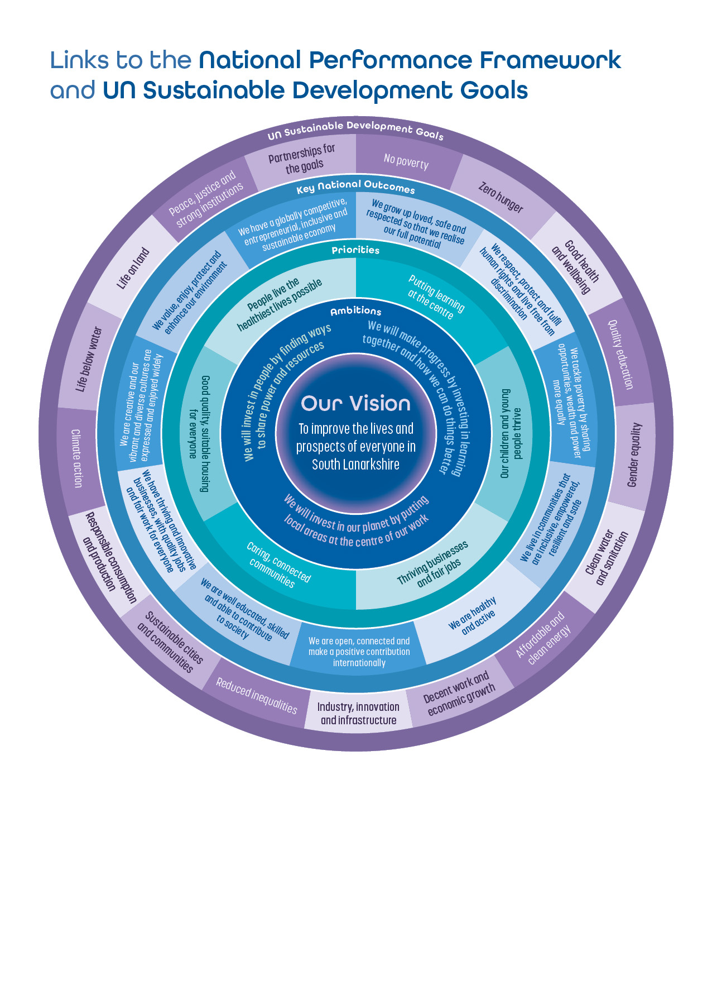

Appendix 2

CPP Structure Diagram



